Driving Economic Development
May 6-10, 2013
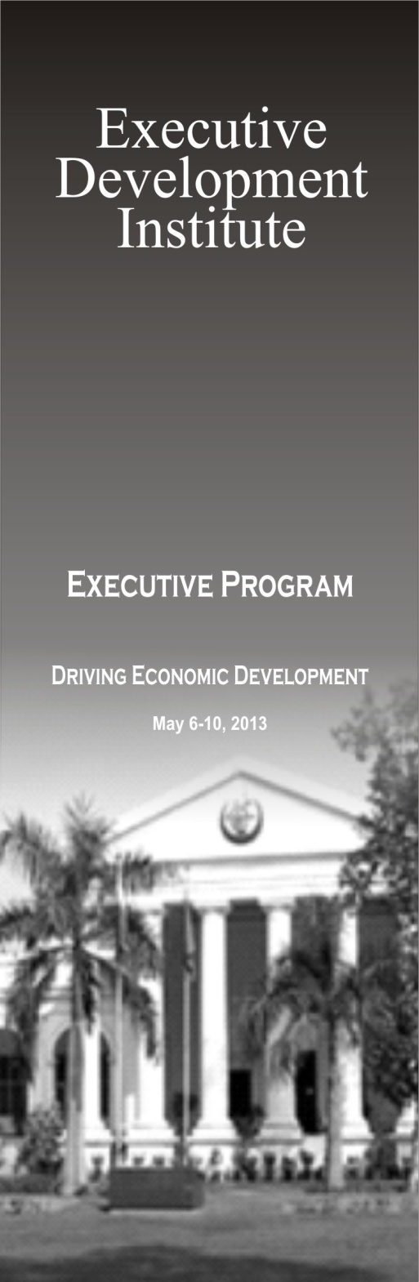

PROGRAMME
Monday May 6, 2013 to Friday May 10, 2013

DAY/DATE | TIME | SUBJECT | MODE | Faculty | REMARKS
Monday  6 May | 1030-1115  1115-1120  1120-1130  1130-1145  1145-1200  1200-1215  1215-1415 | Registration of Participants  Recitation from the Holy Quran  Brief Introduction by Dean-EDI  Inaugural Address by Rector NSPP  Introduction by Participants  Tea Break  Policy Development - I  Driving Economic Development-I :Managing Growth for Macroeconomic Stability |  | Dr. Nadeem Ul Haque | Rapporteur :  Ms. Naureen Ahsan
Tuesday  7 May | 0930-1130  1130-1145  1145-1400 | Driving Economic Development-II: Economic Strategies for Financial Sustainability and Poverty Reduction  Tea-Break  Policy Development - II  Power Sector Reforms |  | Dr. Kaiser Bengali  Dr. Musadik Malik  Mr. Shahid Sattar | Rapporteur :  Ms. Naureen Ahsan
Wednesday  8 May | 0930-1130  1130-1145  1145-1400 | Case Study I – Hubco  Discussion & Consideration in Syndicates  Tea-Break  Presentations by Syndicates |  | Mr. Khalid Jawed  Mr. Tariq Sultan | Rapporteur :  Ms. Naureen Ahsan
Thursday  9 May | 0930-1130  1130-1145  1145-1400 | Policy Development -III  Corruption and Accountability : Impact on National Economy and Effectiveness of Current Institutions  Tea-Break  Policy Development - IV  Corruption and Accountability: Role of Media and the Civil Society |  | Prof. Dr. Ashfaque Hasan Khan  Mr. Talat Hussain | Rapporteur :  Ms. Sameera Sheikh
Friday  10 May | 0930-1130  1130-1145  1145-1400  1400-1445 | Case Study II – PIA  Discussion & Consideration in Syndicates  Tea-Break  Presentations by Syndicates  Certificate Award Ceremony |  | Dr. Salman Shah  Mr. Shahid Hafeez Kardar | Rapporteur :  Ms. Naureen Ahsan

