REGISTRATION FORM
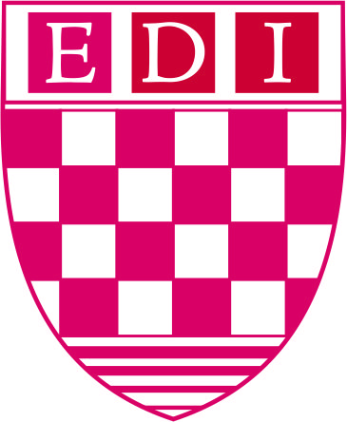
GOVERNMENT OF PAKISTAN
National School of Public Policy
Executive Development Institute

Education
(Start with the most recent qualification only degrees)
Sr.  No. | Dates |  | University / College | Examination passed with year
 | From | To
Course Title: | ONLINE POLICY DIALOGUE WORKSHOP  ‘INTERNAL MIGRATION: ISSUES AND RECOMMENDATIONS’  26TH TO 27TH JULY, 2021
Personal Information
Name |  |  |  | Profession
CNIC |  |  |  | Age
Present Position
Previous Assignment
Organization
(Company address)
Contact Details
Present address

Telephone  (Work) |  | Telephone  (Home) |  |  | Cell:
Fax Number
Email

Please email your form to: directornspp.edi@gmail.com or send it by post to Director, Executive Development Institute, National School of Public Policy, Mall Road, Lahore.

